**East West University**

**Computer Science and Engineering**

**Lab Report 1**

**Submitted by:** Purnendu Bhowmik Shuvro

ID:2023-1-60-085

**Submitted to:** Associate Professor Mohammad Arifuzzaman Ph.D.

Submission date: 15/06/2023

Computer Science and Engineering

1. **Write a complete C program to find area of a circle.**

**Code:**

# include <stdio.h>

int main ()

{

float r, a;

printf("Enter the value of radius: ");

scanf("%f" ,&r);

a=3.142*r*r;

printf("The area of circle is %.2f" ,a);

return 0;

}

**Output:**

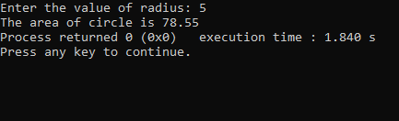

1. **Write a C program to convert a temperature from Celsius to Fahrenheit.**

**Code:**

#include <stdio.h>

int main()

{

float C, F;

printf("Enter the value of C: ");

scanf("%f", &C);

F=(9/5)*C+32;

printf("F: %.2f", F);

return 0;

}

**Output:**

1. **Write a complete C program to solve the equation ax2+bx+c=0**

**Code:**

#include <stdio.h>

#include <math.h>

int main()

{

float a, b, c, u, v;

printf("Enter the value of a: ");

scanf("%f", &a);

printf("Enter the value of b: ");

scanf("%f", &b);

printf("Enter the value of c: ");

scanf("%f", &c);

u=(-b+sqrt(b*b-4*a*c))/(2*a);

v=(-b-sqrt(b*b-4*a*c))/(2*a);

printf("The value of x1: %.2f \n" ,u);

printf("The value of x2: %.2f" ,v);

return 0;

}

**Output:**

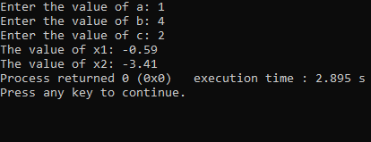

**Conclusion:**

The program is based on learning function and understanding the basic knowledge of C programming language. From this lab, I had learnt about the inclusion of the header files & steps of problem solving.